Using Excel in Urban Affairs
URBS 609

Time frame:
Single class session, Tuesday, September 12, from 6-9 in ACC 125.

Elements:
- Download data from Web into Excel database
  - Use American Fact Finder (linked from http://www.census.gov/main/www/access.html )
  - Select, for the 87 Counties of Minnesota in the 2000 Census:
    - Total population (P1)
    - Median Age (P 13)
    - Household Size (P 17)
  - Download in .xls format
- Clean up and organize data (managing data tables, labeling contents, rotating tables, combining columns, etc.)
- Using formulas & functions
  - Lookup tables (see http://krypton.mnsu.edu/~tony/courses/609/Fiscal/Impaserv.xls
  - Nested formulas (see http://krypton.mnsu.edu/~tony/courses/609/Gravity/Spatial.xls
  - Multiple sheets (see http://krypton.mnsu.edu/~tony/courses/609/LandUse/landuse.xls
- Debugging formulas & error tracking
- Create visual displays of data using F11
  - Pie charts
  - Frequency polygons
  - Scatter plots

HLOOKUP and VLOOKUP

http://office.microsoft.com/en-us/assistance/HA010563201033.aspx

Downloading Data from the U.S. Census Bureau – American FactFinder

- Open a browser to http://factfinder.census.gov/.
- Under Decennial Census, click the get data link.
- Click the Custom Table link on the right side.
- For the geographic type, select County under State on the drop down list

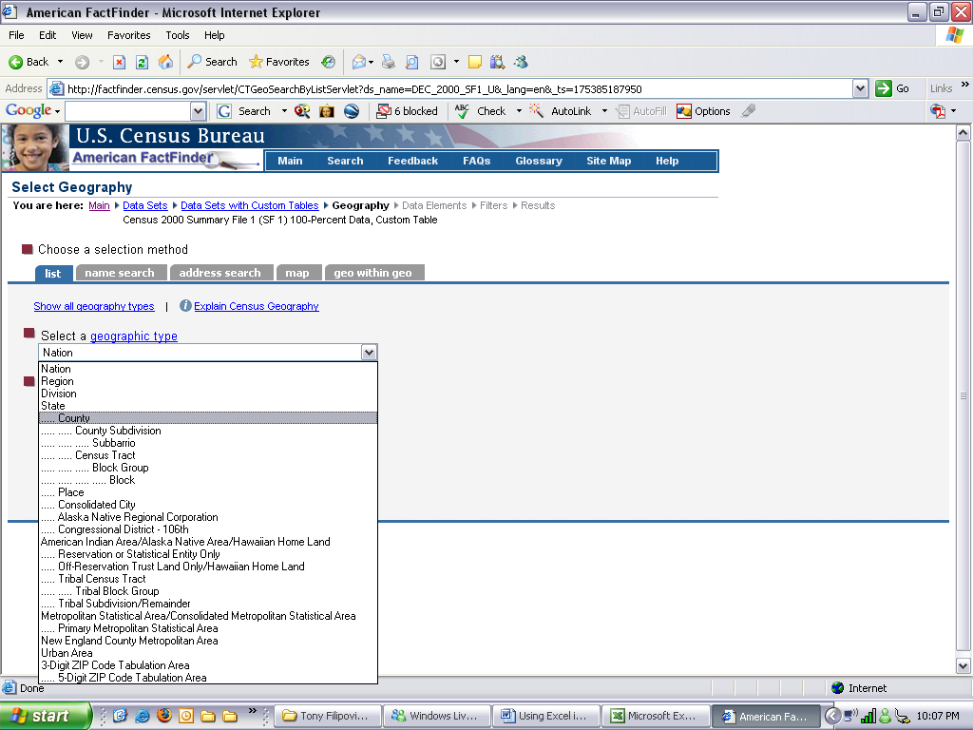
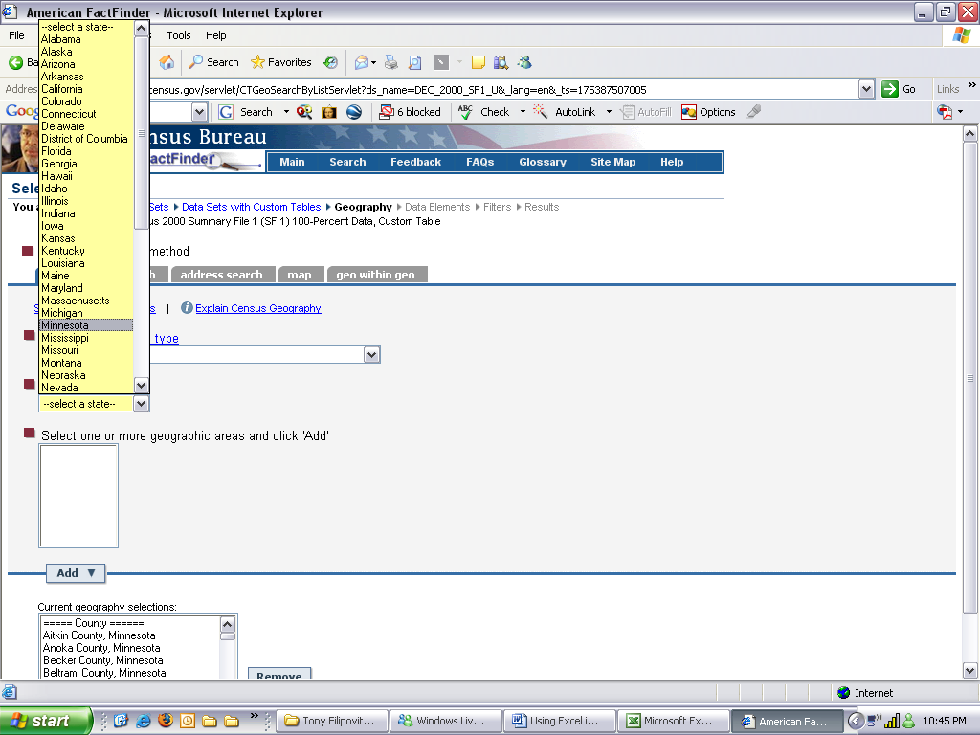
- Select Minnesota for the state.

- Click All Counties and click the Add button. Click Next.
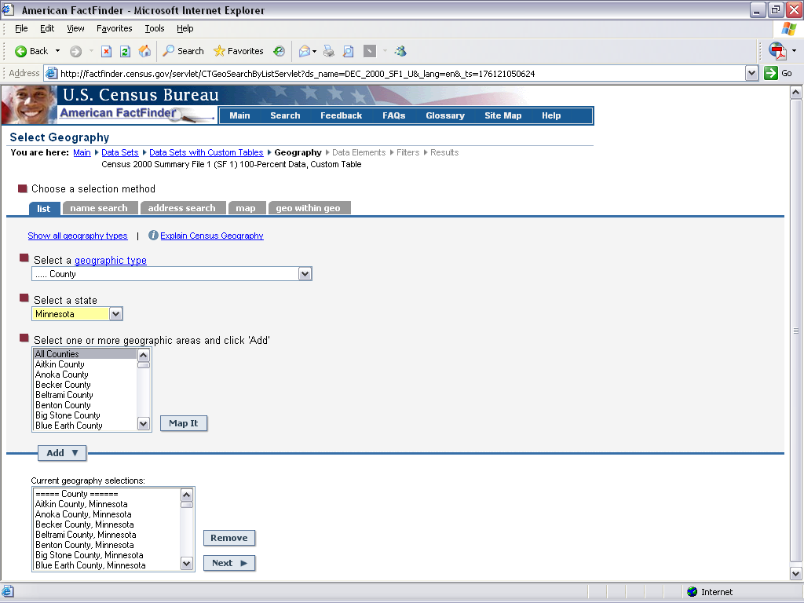

- For this example the following tables will be downloaded: Total Population (P1), Median Age by Sex (P13), Average Household Size (P17). Click the first table. Click Go. Each table needs to be added.
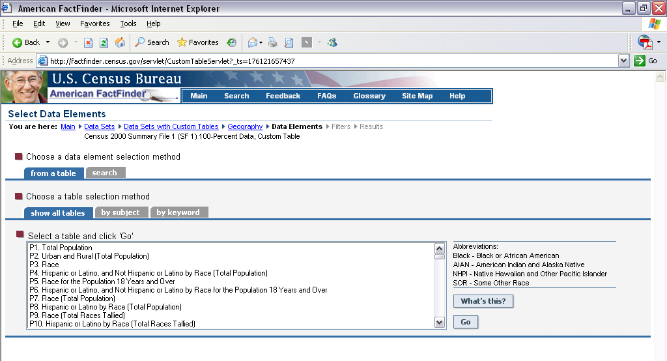
- Click the checkbox next to the data element. Click Add.

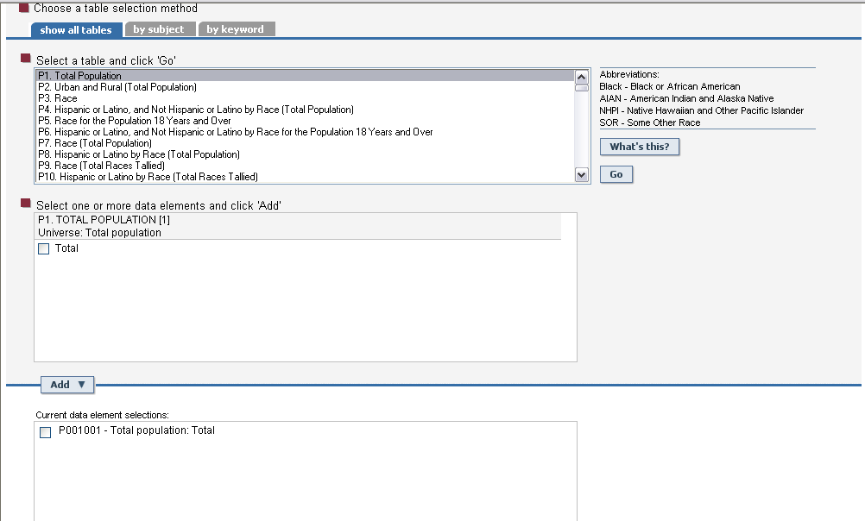

- Click Next when all tables and data elements have been added.

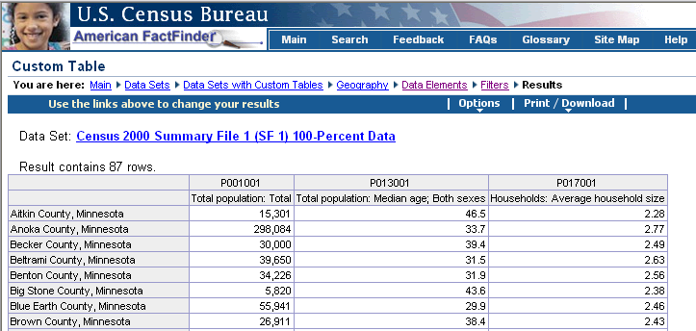
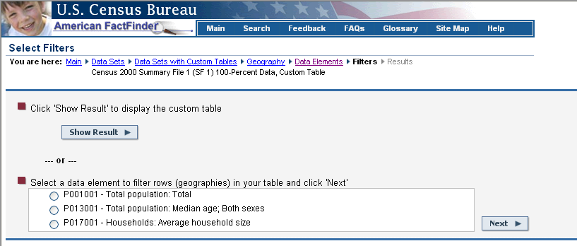

- Click Show Result to view the data.

Downloading to Excel

- Click the Print/Download link.
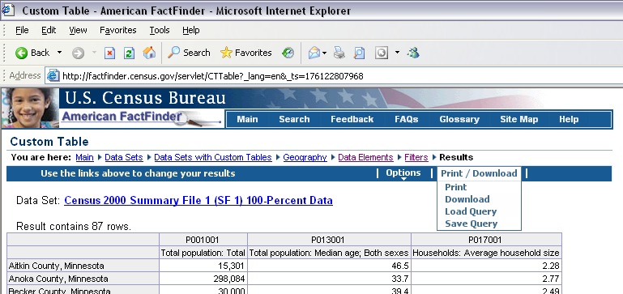

- Click Download.
- Click Microsoft Excel. Click OK.
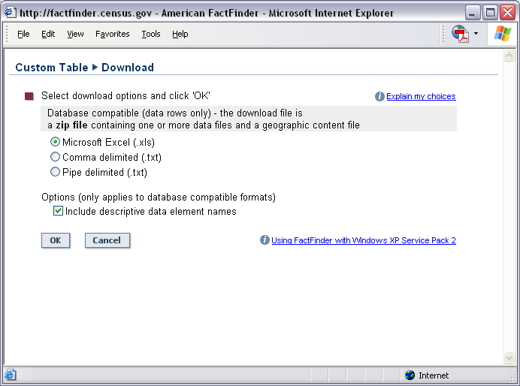

- Click Open. (You may have to allow a pop up by clicking a yellow bar at the top of the screen.)
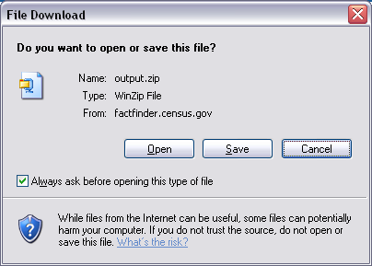

- Click Save and choose a location to save the file to. This will save as a zip file.

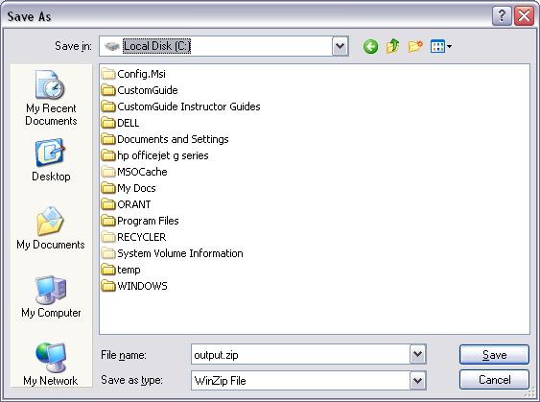

- Double click the file to unzip it. This zip file contains 4 separate files. Save them to a CD, jump drive, etc.
In Excel

- Open the Excel file (data).
- Hide unnecessary columns and rows.
- Adjust column widths.
- Use Edit, Replace to replace “County, Minnesota”.
- Apply formatting. Example: Apply comma style, no decimal places in Column E
- Transposing data:
Copy the data. Click where the data is to be placed. Click Edit, Paste Special and then click Transpose and click OK.
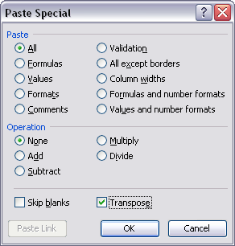

Create a Scatter or Line chart
- Arrange your data so that the x-values are in the first row or column of your worksheet, and the y-values are located in adjacent rows or columns.
- Select the range of x- and y-values that you want to plot in the chart.
- Click Chart on the Insert menu to start the Chart Wizard.
- In the Chart type box, select XY (Scatter) or Line.
- Under Chart sub-type, click the chart sub-type you want to use.
For a quick preview of the chart you are creating, click Press and Hold to View Sample.
- Click Next, and continue with steps 2 through 4 of the Chart Wizard.
For help on any of the steps, click the question mark (?) on the Chart Wizard title bar.



Creating Charts with Excel 2003

This handout is simply an outline to be used as a guide in class. Microsoft Excel offers many ways to accomplish different tasks. The steps below identify at least one way to accomplish a task in Microsoft Excel. We will explore as much of this program as time allows.

Charting

Charts are visually appealing and make it easy for users to see comparisons, patterns, and trends in data. Before you create a chart, you must arrange the data on your worksheet for the type of chart you want to use. For more information go to Excel help and type Create a chart.

Embedded Charts and Chart Sheets
You can create a chart on its own chart sheet or as an embedded chart on a worksheet. Either way, the chart is linked to the source data on the worksheet, which means the chart is updated when you update the worksheet data.
A chart sheet is a chart that can be created in one step. It is a separate sheet within your workbook that has its own sheet name. Use a chart sheet when you want to view or edit large or complex charts separately from the worksheet data or when you want to preserve screen space as you work on the worksheet data.
To create a chart sheet:

- Select the data to be included in the chart.
- Press F11 on the keyboard. A chart sheet is created using the default chart (column chart).

An embedded chart is considered a graphic object and is saved as part of the worksheet on which it is created. Use embedded charts when you want to display or print one or more charts with your worksheet data.

To create an embedded chart using the Chart Wizard:

- Select the data to be included in the chart.
- Click on the Chart Wizard button on the Standard toolbar.
- From Step 1, choose a chart type and chart sub-type then click Next.
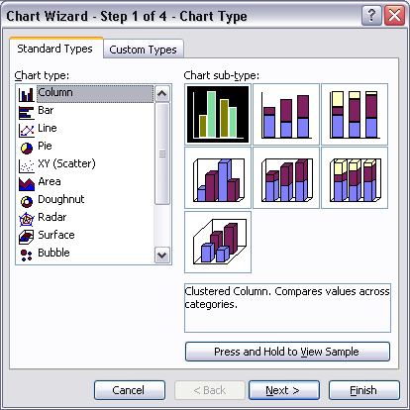

- In Step 2, confirm or change the data range or series configuration then click Next.
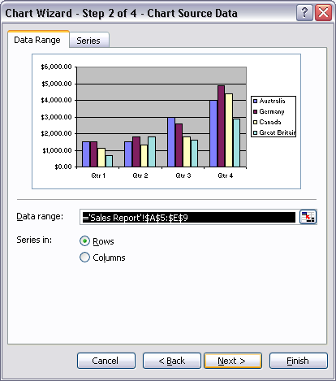

- In Step 3, make any changes to the titles, axes, gridlines, legend, data labels, or data table then click Next.

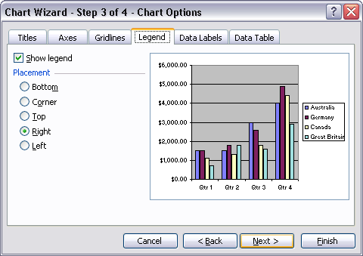
- In Step 4, choose the location for the chart then click Finish.

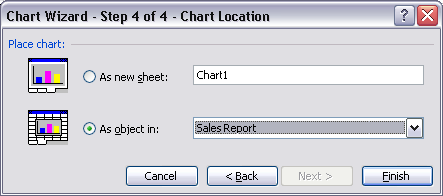

- Once you click Finish you will have created a chart based upon the data you selected in Step 1. When you create a chart the Chart toolbar should open automatically. If the toolbar does not open, click View, Toolbars, Chart to open the Chart toolbar.

data marker: a column, bar, area, dot, slice, or other symbol in a chart that represents a single data point or value that originates from a worksheet cell. Related data markers in a chart constitute a data series.

data series: related data points that are plotted in a chart. Each data series in a chart has a unique color or pattern and is represented in the chart legend. You can plot one or more data series in a chart. Pie charts have only one data series. Example: all of the purple columns

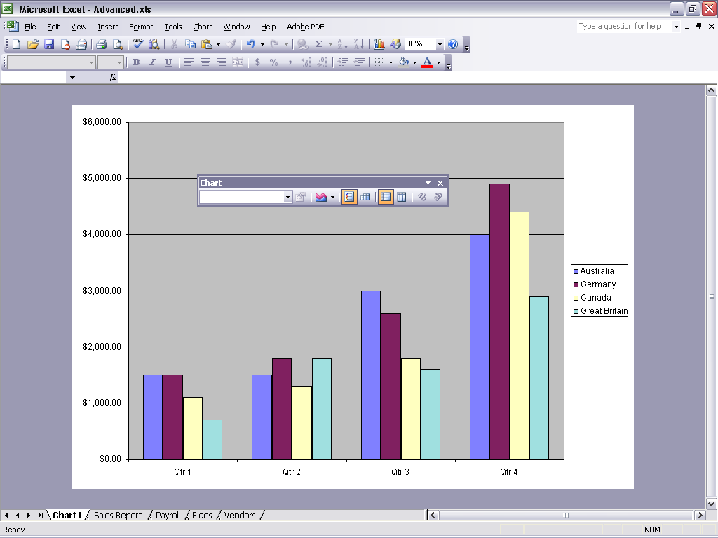

Using the Chart Toolbar

Several aspects of the chart can be changed by using the Chart toolbar.

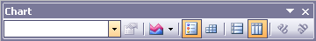

1. 2. 3. 4. 5. 6. 7. 8. 9.

- A drop down box that is used to select objects on the chart.
- Format legend button opens the format box so you can change the font, size, color, etc of the legend.
- Chart type button is used to change the type of chart after the chart has been created.
- Legend button is used to turn the legend on and off.
- Data Table is used to turn the data table on and off. A data table is data used to create the chart.
- By Row
change the order, placement, and worksheet orientation of data series in a chart.
- By Column
- Angle Clockwise will rotate the axis titles clockwise.
- Angle Counterclockwise will rotate the axis titles counterclockwise.

Creating Graphic Objects

Graphic objects can be drawn on a chart using the Drawing toolbar. Many different shapes can be drawn using the tools on the Drawing toolbar.

To turn on the Drawing toolbar:
- Click on the Drawing button on the Standard toolbar.

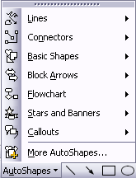
To draw an object:

- Click one of the objects or shapes on the toolbar.
- Place your mouse on the worksheet where you want the shape to appear.
- Click and drag the mouse until the shape is the desired size.

Quick Tip: To format any object on a chart, double-click the object. This will open the Format dialog box with options to format the selected object.

