Reconnaissance Essay
Tony Filipovitch with Kathy Harris

Walkabout Observations—AIC Gardens
We came at the Art Institute of Chicago from the Crown Fountain in Millenium Park. We crossed Monroe and proceeded around to Columbus.
- As we approached the museum, it was apparent that it had been added onto, probably several times. One façade had intricately carved details in Beaux-Art style, while another façade (in similar stone) was mostly unadorned, and a third façade was glass-and-steel.
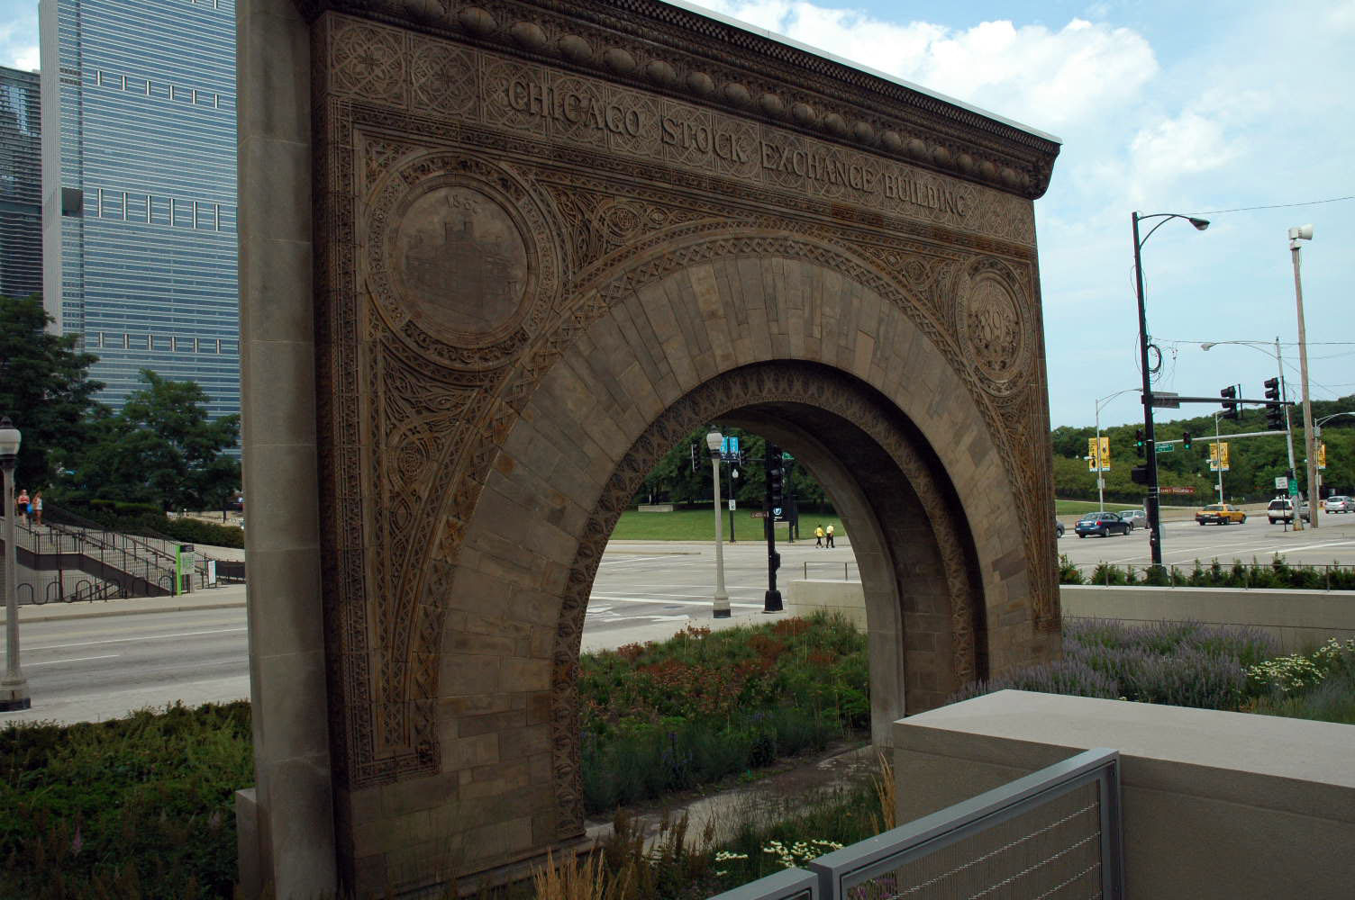
- At the corner of Columbus & Monroe, there was a large, free-standing arch, faced in one side in marble similar to that on the AIC. The other side of the arch was part of the original façade from the Chicago Stock Exchange. There was an irregularly shaped garden around this arch, with plantings of native species (daylilies, astilibes, Echinacea, etc.). The garden was mostly mid-level plants and grew up to the sidewalk on all sides. There was no place to sit, or really even to tarry, and there were no trees to shade the surrounding sidewalk. The garden appeared to be one for viewing as one passed along sidewalk.
- Further south on Columbus, there was a U-shaped space between two wings of the AIC building. The open end of the U was blocked by a fence of iron rods, so one could see into the space but not enter it. This garden space was planted with hummocks of native grass along three sides, with a stone patio coming out from the building on the fourth side. There were café tables scattered about on the patio. There was a man pacing in the garden, speaking aloud and referring to a sheaf of papers in his hand—apparently he was rehearsing a speech.
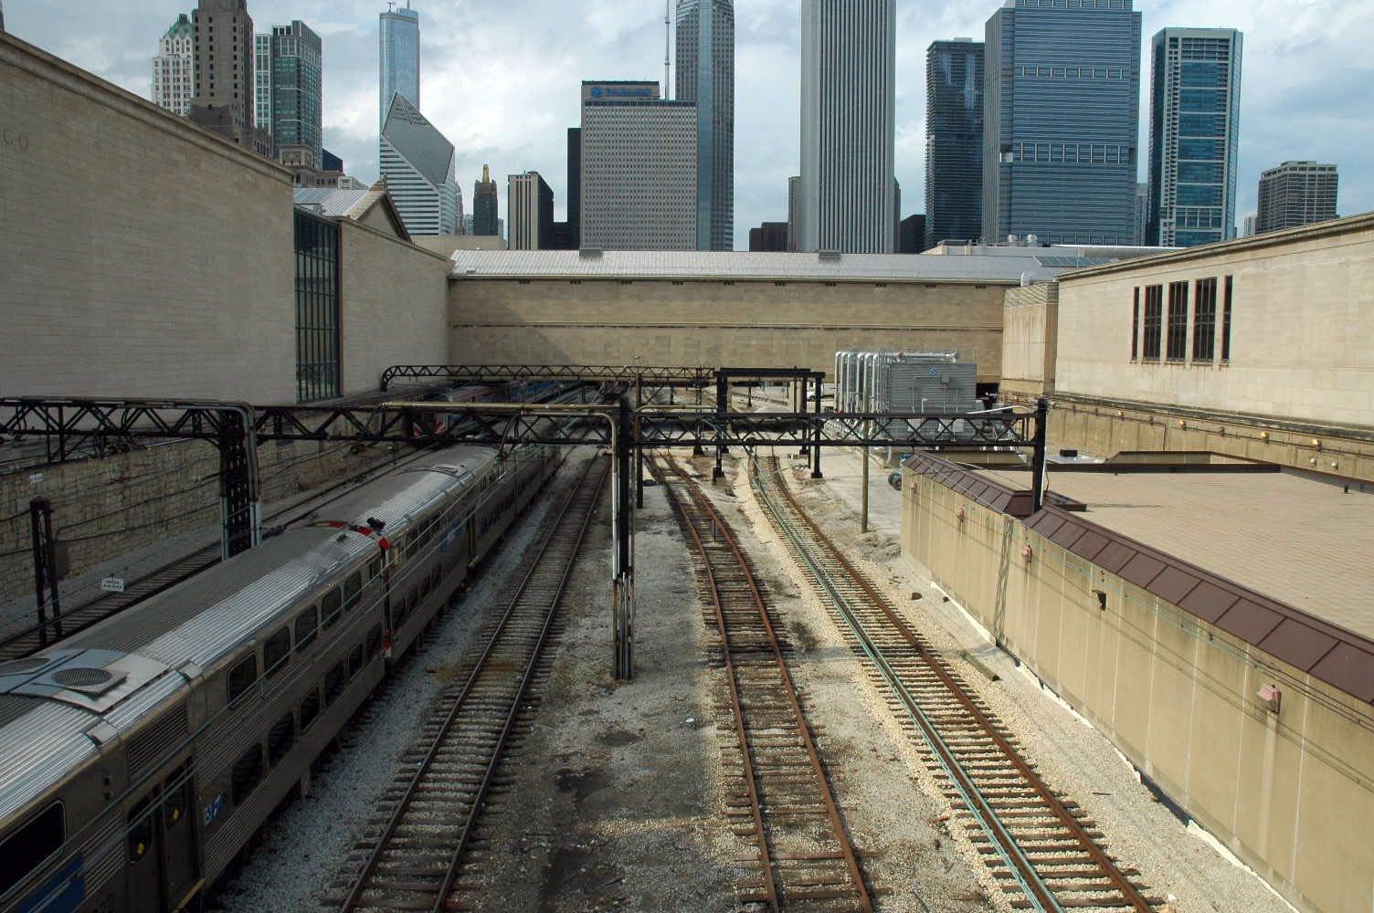
- There were a few people, mostly young adults, at least some apparently students at the Art Institute School (one was smeared in paint, on her shorts & tank top as well as on her legs and arms), as well as some tourists (a family of an older man with white in his hair, a couple and two early-teen boys were taking a family photo with the arch in the background). At the corner of Jackson & Columbus, we saw a Segway tour of about a dozen people waiting for the light to change, and as we turned on Jackson we found another Segway tour in the middle of the block. From Jackson St. (the south boundary of the AIC), we could see the Metra tracks that split the AIC into two sections, and then run under the street at Columbus (the tracks were not apparent from the north side). Here again, one could see the different periods in building construction, and surmise an even earlier period since the railroad tracks were so far below the grade of even the earliest part of the AIC building.
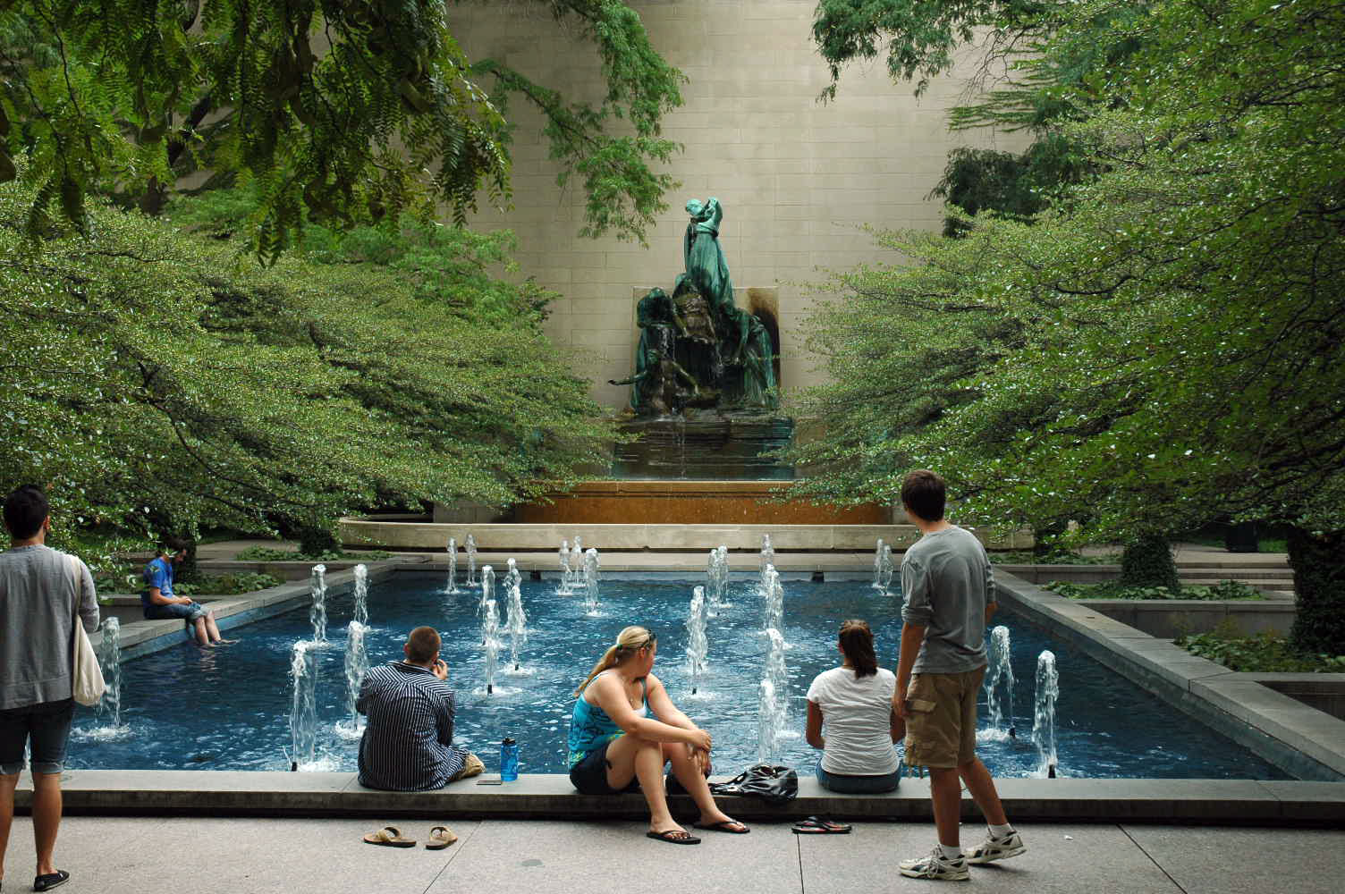
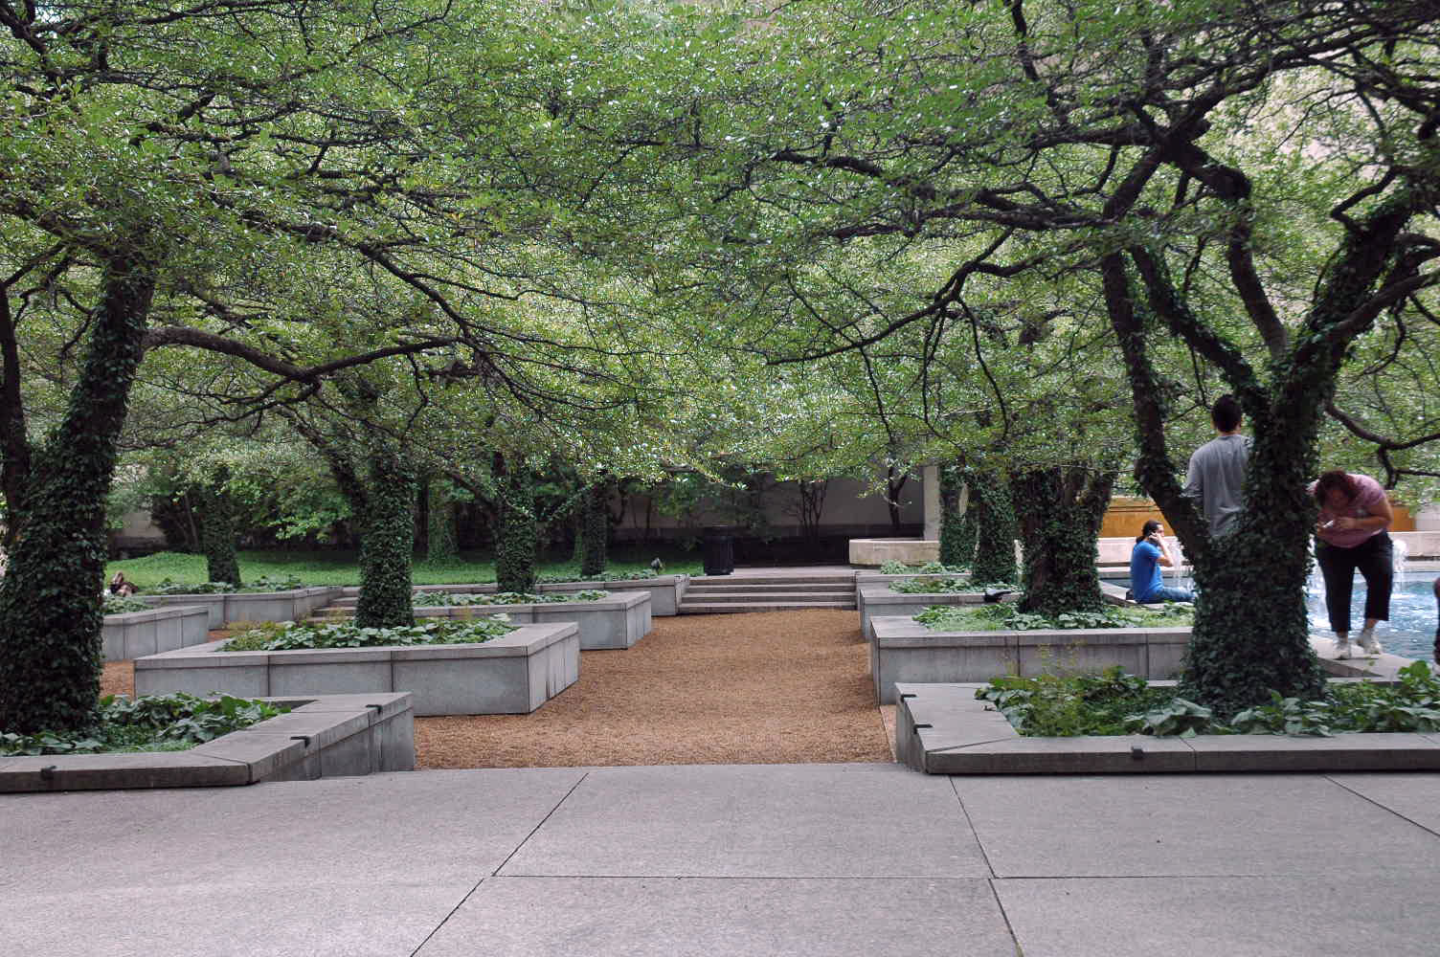
- At the corner of Jackson and Michigan, there was another garden. This one was much more formal in its layout—4 rectangular beds, divided by a rectangular pool with a water sculpture at its head. Unlike the arch garden, this one was separated from the sidewalk by a pruned evergreen hedge. The garden beds were planted with a number of low trees (perhaps dwarf crabapples, although I did not notice any fruit) which had ivy growing up their trunks. There were benches for sitting (one person, middle-aged male, was sitting on one of them) and a group of 8 young adults were spaced in groups of 2-3 around the pool, with their feet in the water. The trees created a low canopy which provided shade and even a feeling of mystery, and the canopy and the hedge filtered the street noises so that one could hear the water splash in the fountain—when the brakes of the buses didn’t drown it out.
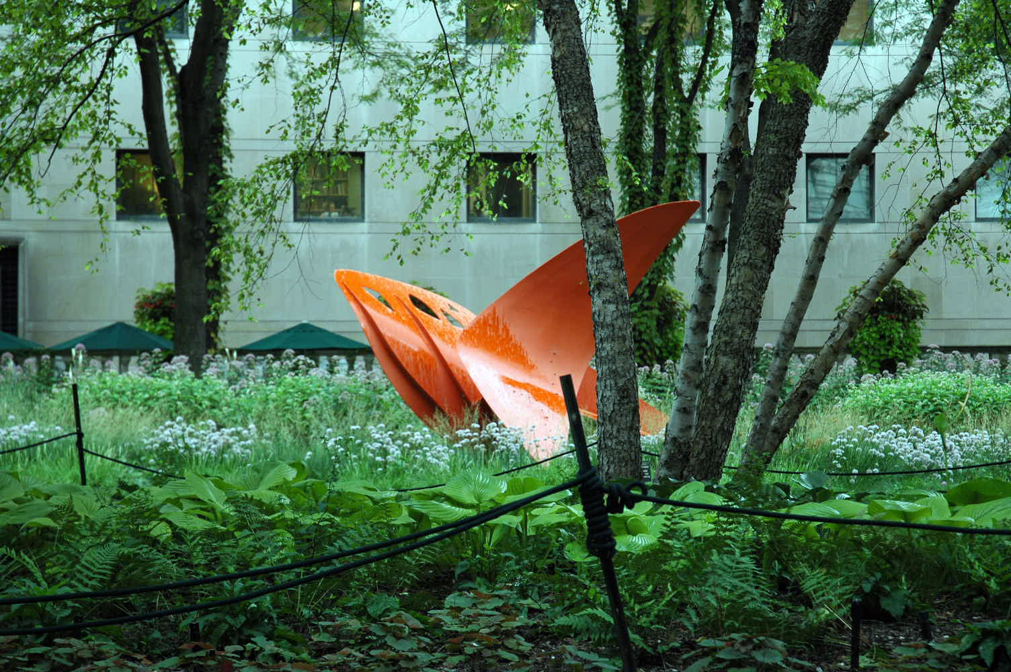
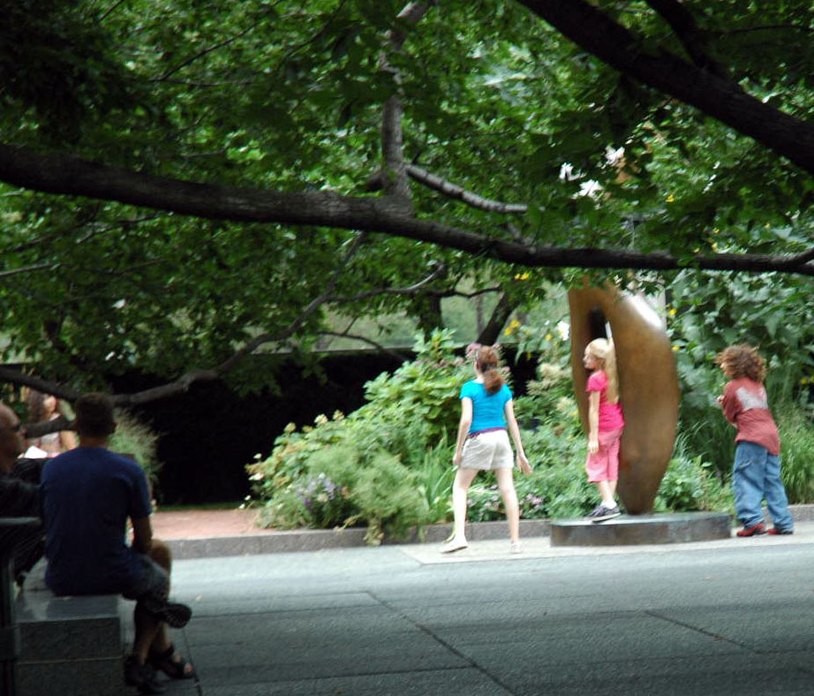
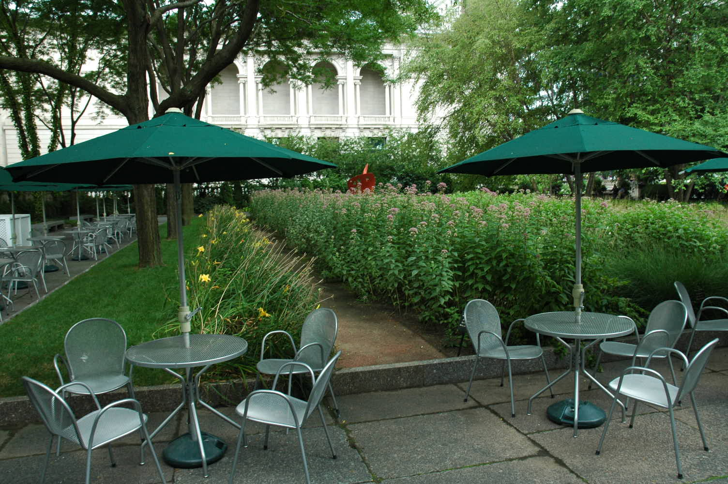
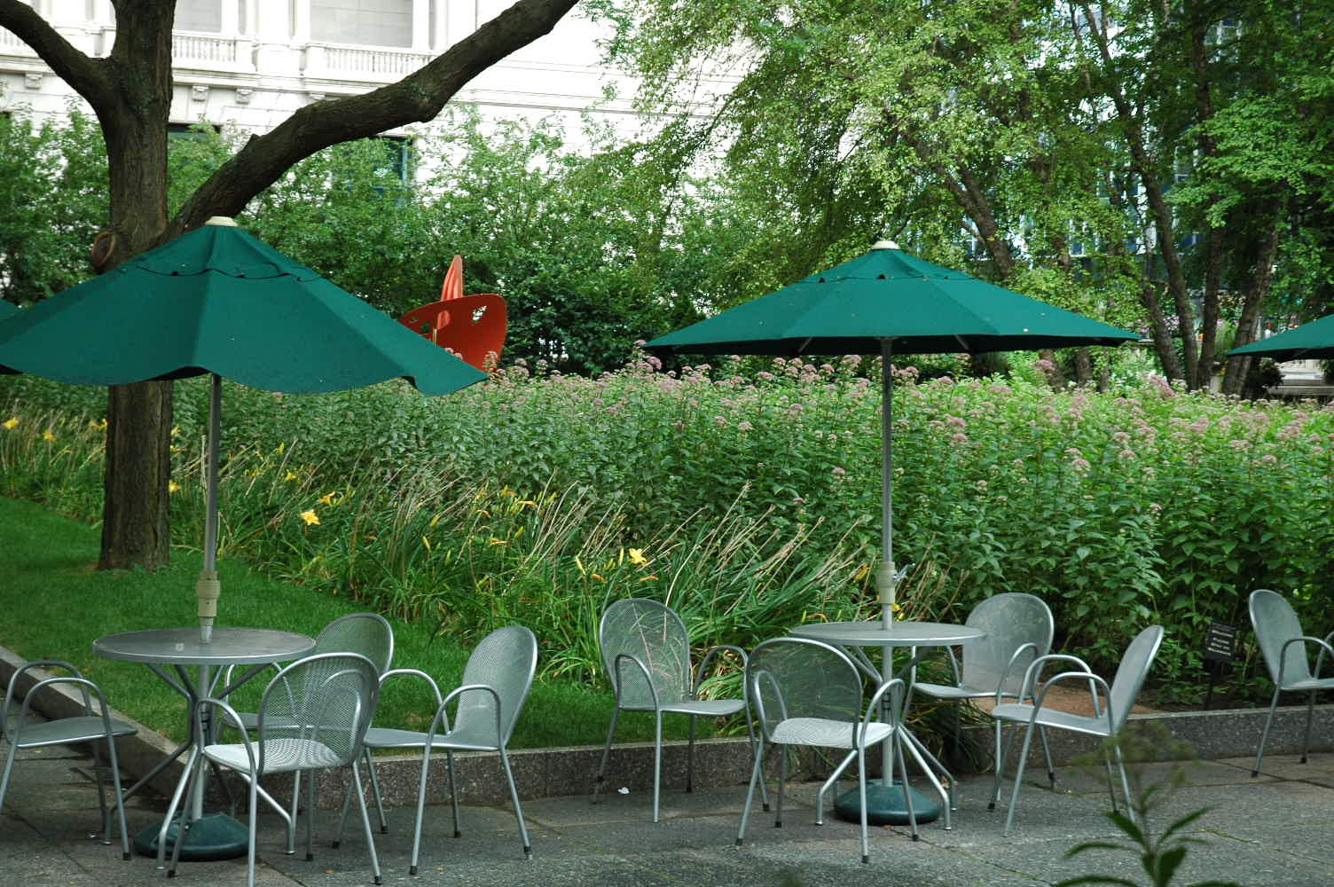
- On the north side of the AIC on Michigan Avenue there was yet another garden. This one was also behind a hedge, but was less formally laid out. There was one very large, overhanging tree which shaded almost half of the garden, and a number of smaller trees (including river birch) in the remaining area. The plantings were native species (again, daylilies and astilibe and Echinacea and this time alliums), but curiously they were planted in separate rows. When viewed from the end of the rows, the effect was …. Unexpected. Such a formal planting for such informal plants. But viewed from the side the massed plantings worked very well. There were also sculptural pieces by Calder and Moore, along with some benches and a number of café tables with umbrellas. There was a troupe of 8-10 children playing “Statue-tag” on a turf area when we arrived. As they finished their game and left, several of them climbed into and around the Henry Moore sculpture. Meanwhile, under the spreading tree canopy, a middle-aged woman was practicing yoga. And there were several people at the tables—a young woman who was multi-tasking (her earbuds were in, she was checking the images on her digital camera, and her cell phone was out on the table), two men in their thirties (one of which was talking on his cell phone—for the entire time we were there), and a grey-haired couple who were sitting quietly opposite each other, one reading a newspaper and one reading a magazine. Here again, the traffic was reduced to a low hum (except for the bus brakes) and the sounds of the water and the children at the neighboring Crown Fountain could be heard.
- In terms of context, the AIC is bordered on the east by Grant Park, and beyond that the Lake. On the west, it is bordered by early 20th Century buildings, like Burnham’s People’s Gas Bldg, several of which have had stories added atop the original structure. And, behind Michigan Ave, the glass & steel towers of the modern city rise.

Reflection
- In terms of context, I am struck by the way the new is grafted to the old—when it is permitted to remain at all. Looking to the north, the tall glass-and-steel skyscrapers show no memory of what used to be there.
- In terms of the gardens, there is a progression (regression? Devolution? Reawakening?) from the SW corner garden (the formal, French-style garden with the pool and fountain) to the NW corner (still with formal turf and strict arrangement of plants, albeit native species) to the east side (native plants in informal array). The east side is the new side of the AIC, and perhaps is a reflection of Chicago’s growing awareness of the issues of energy consumption and climate change (Chicago has a very ambitious sustainability plan, and hopes to become one of the first energy-neutral big cities in the US).
- In terms of the private use of public space, the formal gardens on the west side invite the passers-by (who are in the know—these gardens are screened from the street) to sit and tarry, mostly in solitary or fairly small-group activity. They are purposely created as oases in the urban hubbub.

