Neighborhood Observation
Ukrainian Village
Tony Filipovitch, with Wolf Gumerman & Donna Schonerstedt

Description
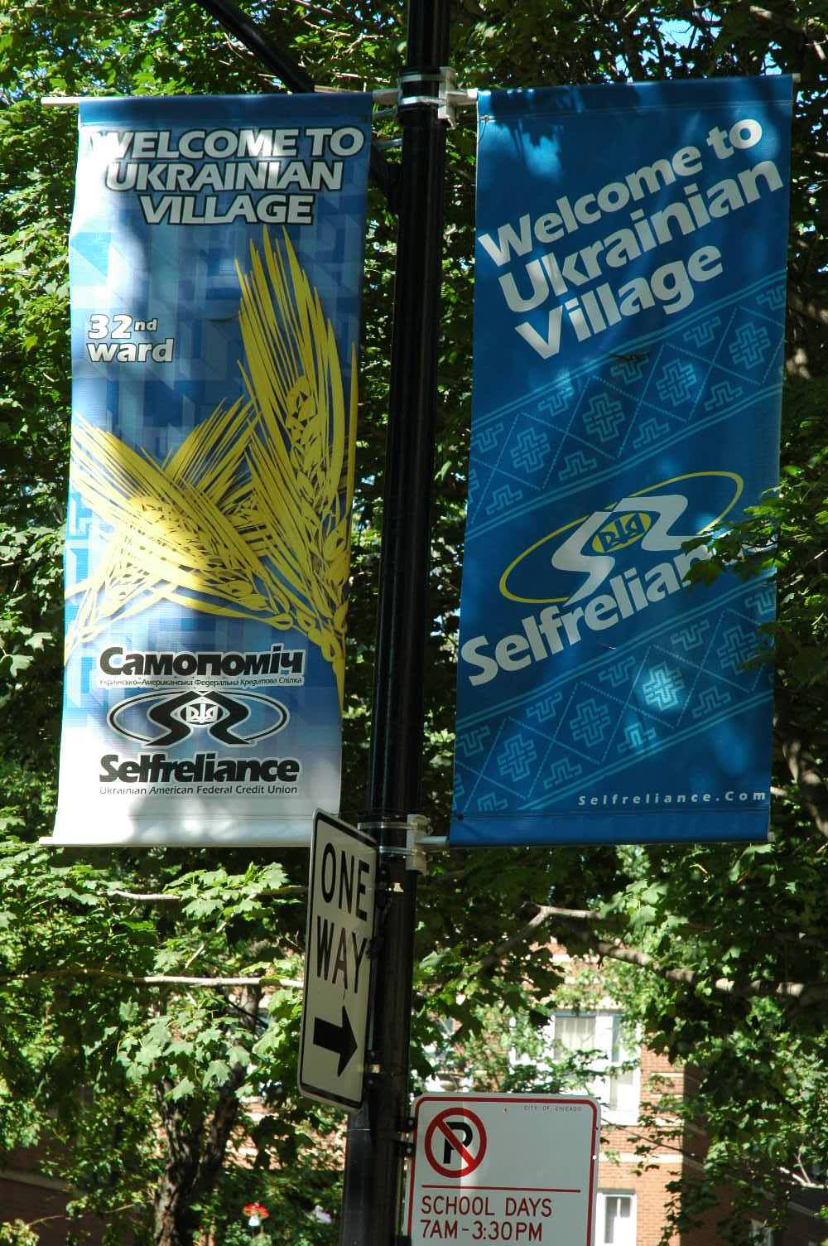
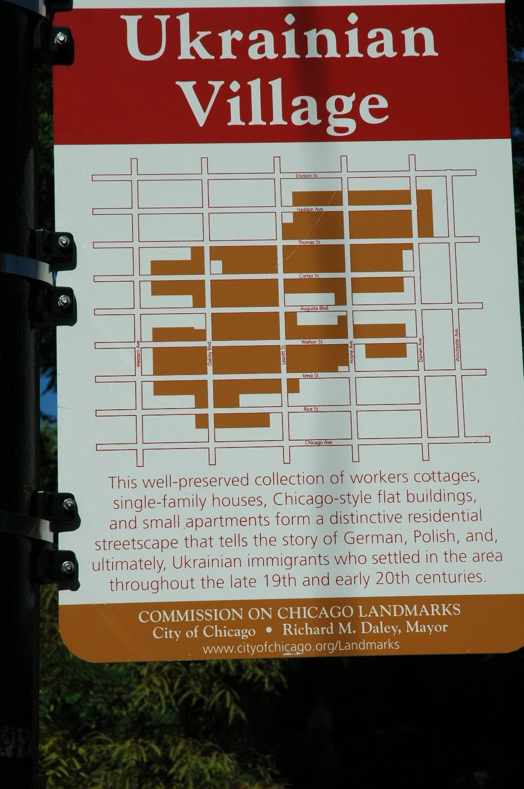
The Ukrainian Village neighborhood is roughly a ½-mile square, bounded by Division to the north, Damen to the east, Chicago to the south, and Western on the west. The streets are all laid out on a regular grid pattern, the blocks are of moderate length. Almost all of the commercial activity is on these streets, or on Augusta (which runs E/W and bisects the neighborhood). While residences on Division are mostly confined to the upper stories (shops are on the first floor), the other streets mix purely residential buildings among the commercial uses. There are no parks, but there are three churches (plus one abandoned one) and a hospital.

Coming into the village from the northeast along Division, one travels along a street in transition. Near Ashland there are several large vacant lots on the streetscape, but also one new glass-and-steel 3-story commercial building and another coming out of the ground. At 9AM, there was also at least one local sitting at a table in the window of his local tavern. Traveling west toward the Village, the shops are newly renovated and increasingly upscale, including a bakery that offers cakes decorated to look like a hamburger-and-french-fries meal and a bustier, among others. A property agency lists a few rentals in Ukranian Village, offering them for $1600-$2000 (I found one on Craig’s list for $1500). The agency’s posters feature photos of potential customers—a gay couple in their twenties and a young mother-daughter pair.

Most of the people we passed on the streets in the northeast side of the Village were an indistinguishable mix of white Americans, but I also began to see people with identifiable Ukranian appearance—a young man who looked Russian, a young woman who had some Mongol features, and a woman with Galician (Celtic) features. No one (Ukrainian-appearing or not) looked directly at strangers on the street, but if we engaged them with questions they answered freely. The first people we accosted with questions were 20-30-somethings who were walking dogs. It seemed that they were simply used to ignoring strangers. Further into the neighborhood, we came upon groups who were speaking Ukrainian among themselves and seemed shy around English-speakers.

There were at least 2 rental signs on every block; some buildings were vacant with signs on door redirecting deliveries. In the northeast corner, we came across one house on an alley with children’s toys in backyard; there may have been other houses similarly outfitted, but most yards were tucked behind the houses and not observable from the street. Another house in this area had potted tomatoes near the stoop and the boulevard was planted in vegetable gardens. The owner, a Southeast Asian, was happy to share information about the varieties he had planted (one was a sweet potato that was eaten for its leaves, not its root).

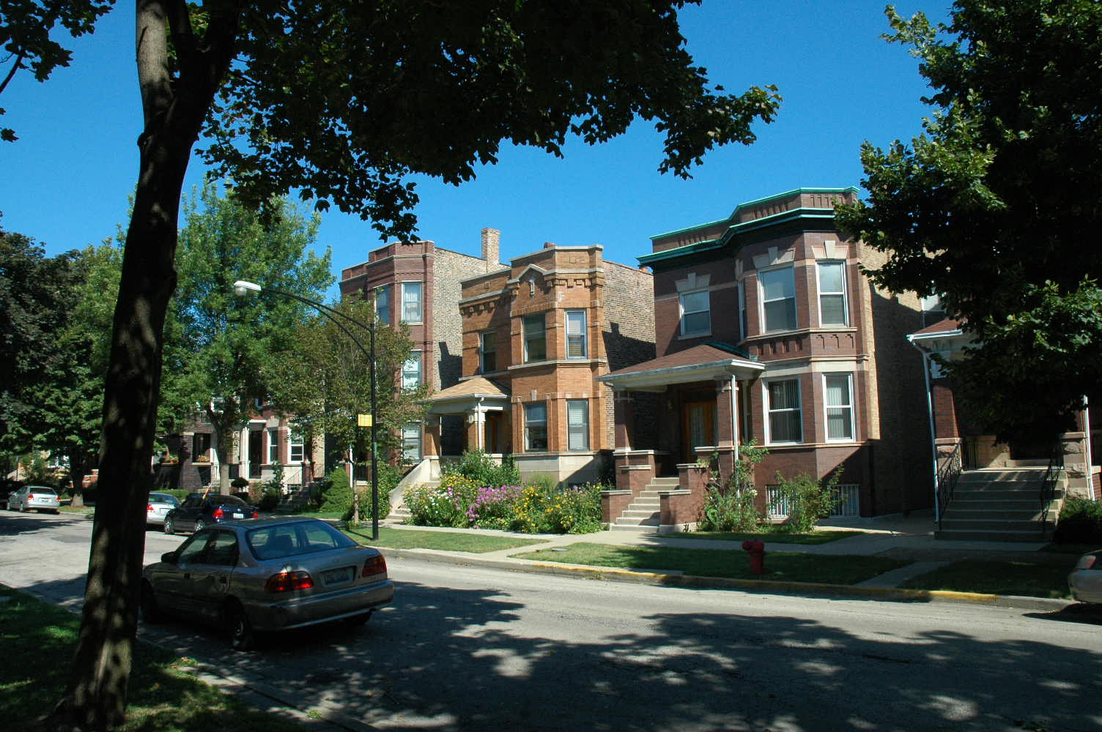
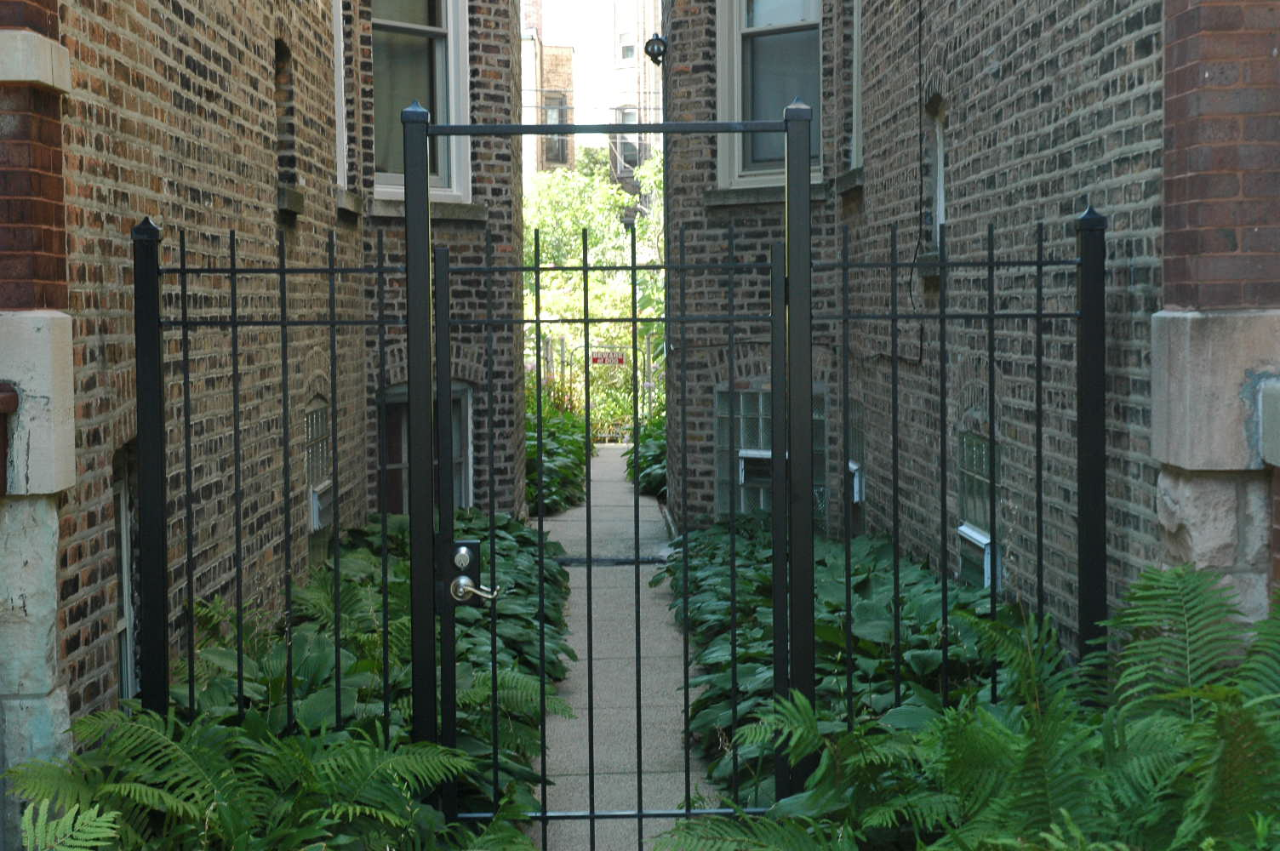
Throughout the neighborhood, most residential buildings were in excellent shape, their facades renovated or well maintained. Those that were not were in the middle of restoration (but it was not possible to tell how long “in the middle” has been taking). The yards & trees are neat and trimmed, clearly cared for. There are gardens on the sides, in the back, sometimes in front spilling onto the boulevard. Bungalows are mixed with duplexes, sometimes with apartments on corner lots. There are several mansions, one proudly displaying its plaque from the National Register of Historic Places. Several houses had security cameras on entrances (one of the dog-walker took them as a matter of course, although he still claimed the neighborhood was safe). Another yard had a chain-link gate with a “Beware of Dog” sign at the side of the house in the back, and another iron gate 40 feet up the walk at the front corner of the house. We also noticed some Ukrainian decorative influence on several buildings, and a Ukrainian flag on a car

Augusta Blvd., the street that bisects the neighborhood, had bungalows & duplexes along its face, and some new infill housing. Columbus school was also on this street in the middle of the neighborhood. A painted bike lane ran on both sides of the street.

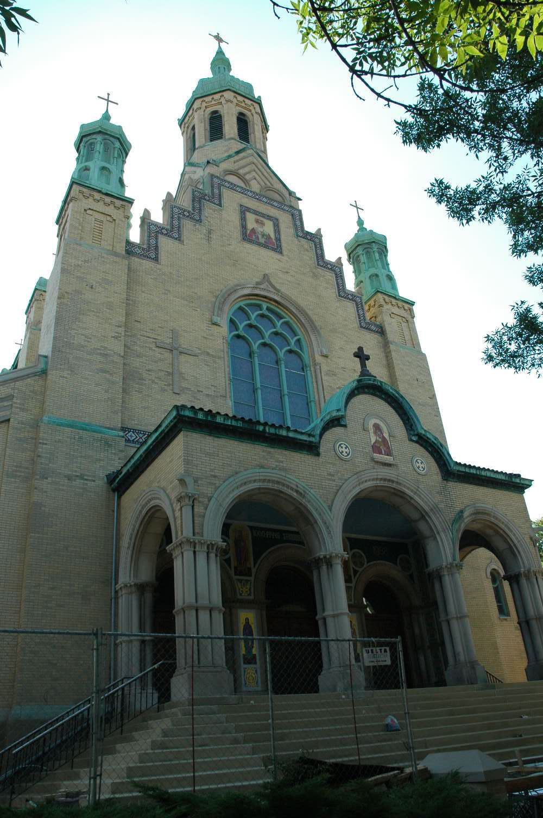
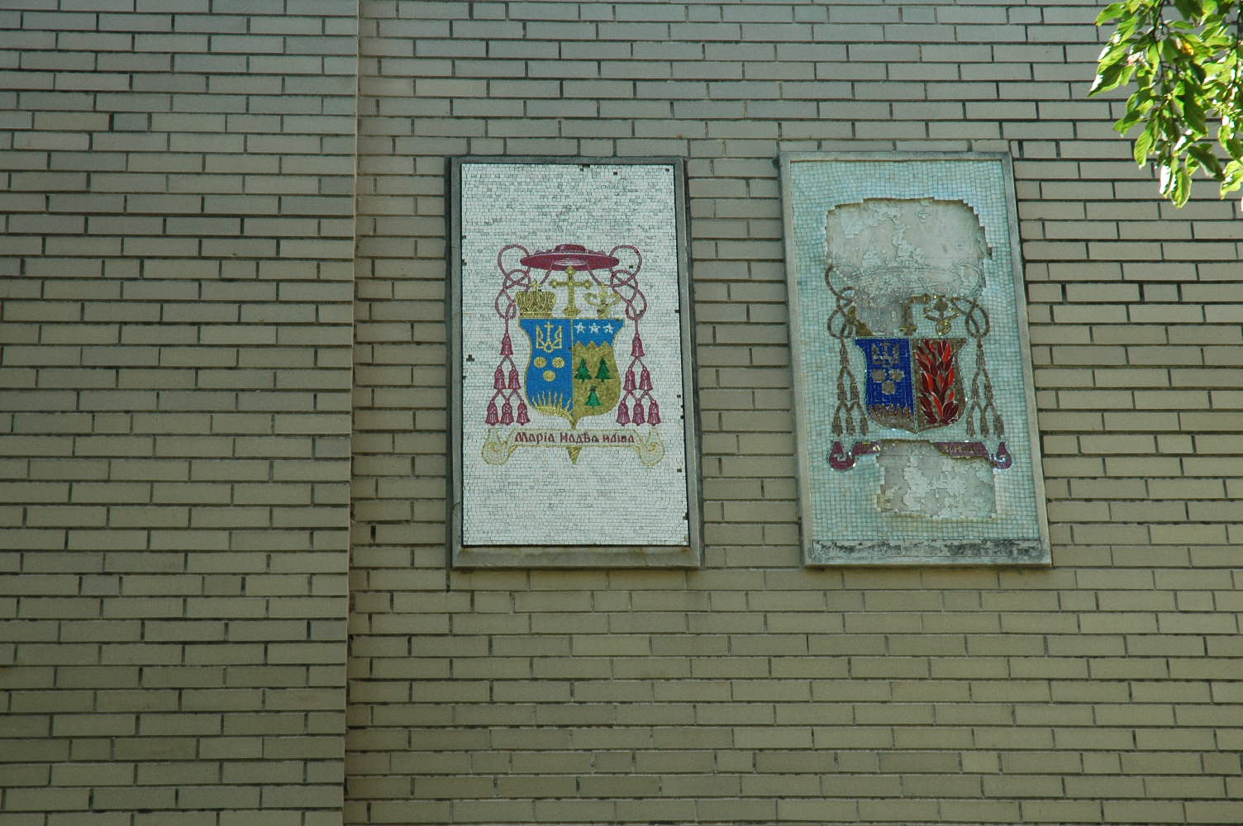
In the southwest corner of the Village is St. Nicholas Church. The cornerstone says it was founded 1913, and added to several times since then. It is built in the style of a Cossack church. The rectory across the street has two bishop’s coat of arms (one effaced), indicating that it is a cathedral church which has had two bishops, the first one having died. There is also a parochial school and a Saturday Ukranian school. We noticed leaflets posted on the boulevard trees around the Church and rectory, reminding dog walkers of the penalties for failing to clean up after their animals.

As we moved to Chicago Ave. (the southern boundary of the Village), we saw a pre-teen and a young teen boy speaking Ukrainian to themselves and then to their father as they get into car, and later 3 elderly people walking along street speaking Ukrainian.
There are a lot of vacancies among the commercial buildings on Chicago Ave.—the only grocery store is abandoned and the door is covered in graffiti (but there is still Annie’s Bakery, which sells a range of food). There is an Independent Radio station and Ukranian posters and a money exchange with signs in Ukranian along this street.

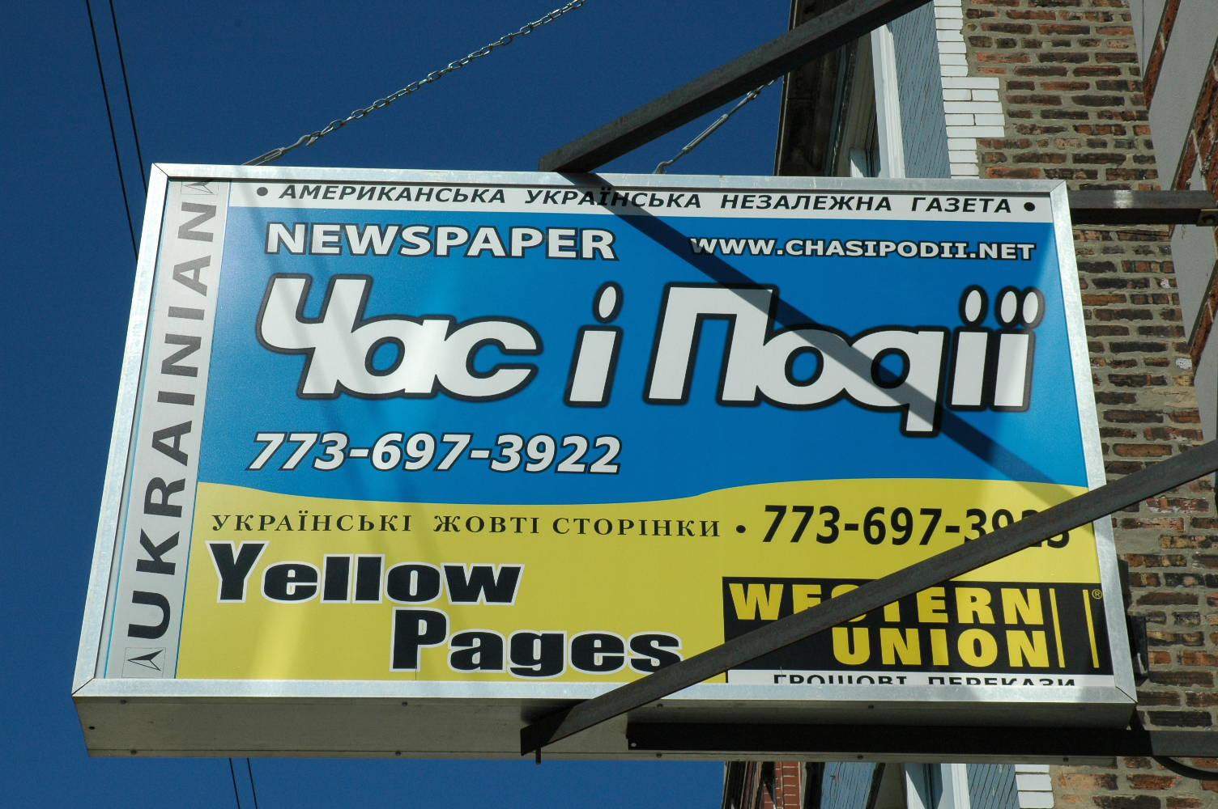
We stopped in at the Ukranian newspaper building. We met a young woman, Svetlana, who was a lawyer at home but is a journalist here. She came to be with other family (her mother came earlier as displaced person, resettled by the Catholic Relief Agency). She explained that there have been 5 waves of immigration (1890s, after WWI, after WWII, after Perestroika, and recently during the Recession). The most recent wave of immigrants tend to speak English well, having studied it in school; the older immigrants learned German or French (and Russian) in school, and many speak no or very little English. The older immigrants in the Village (who were forced to leave by the civil chaos when the Soviet Union fell) did not entirely approve of the more recent immigrants, some of whom had made good money back home in construction and came to the US as investors and entrepreneurs. They feel that these successful young people belong back home, building democracy in the Ukraine. There are at least 3 generation of Ukranian property owners in the Village, and many are recent purchasers who are now in financial distress as the recession has impacted their construction businesses.
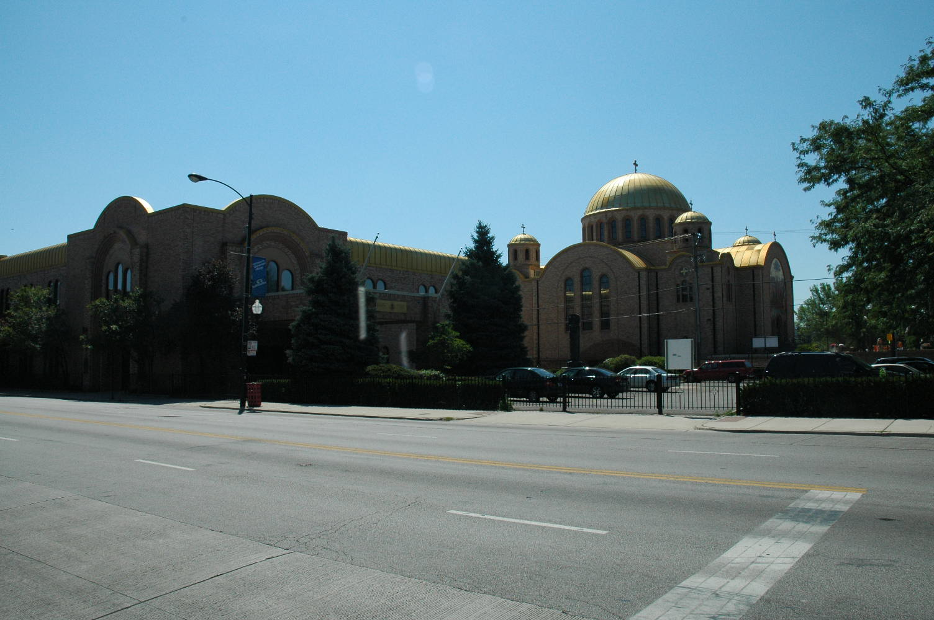
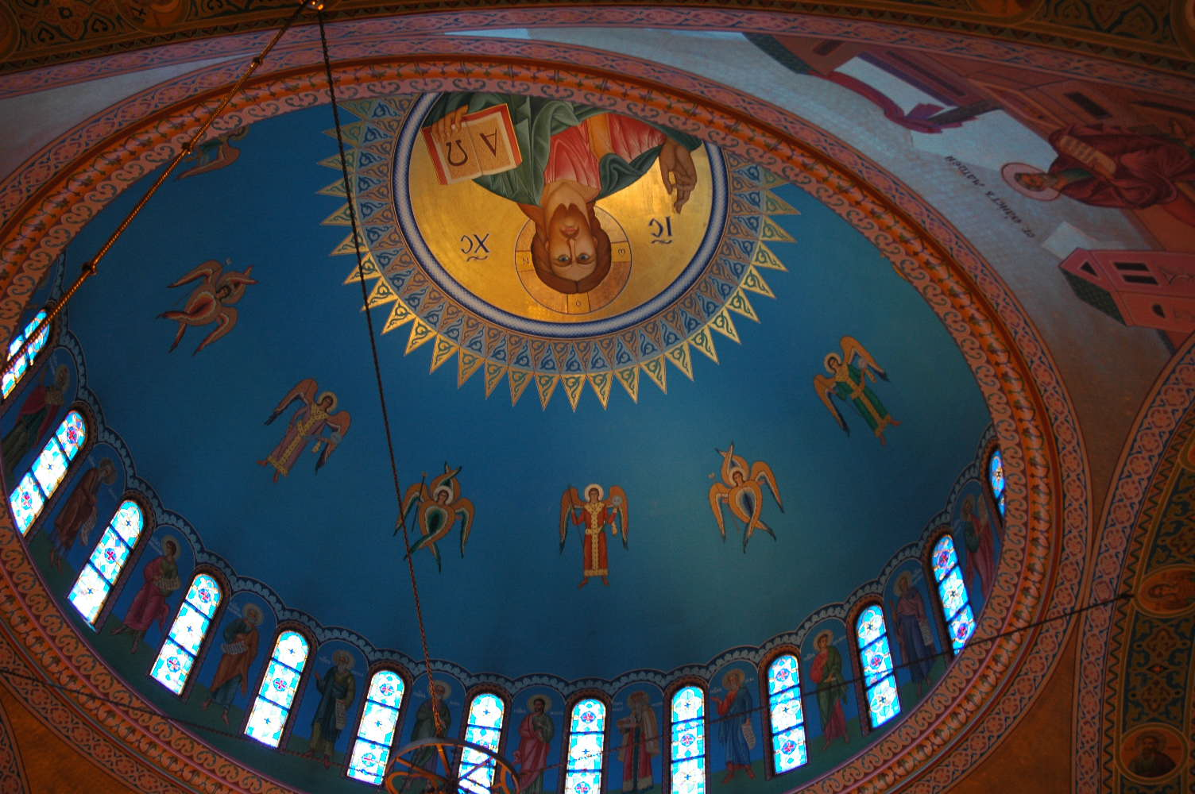
On the south side of Chicago Ave. is the church of St. Volodomir & Olha, founded in 1964. While exploring the parish hall, we asked an older gentleman why there are two churches so near each other. He bowed his head and sighed, and said that it is a long story, but the older church adopted the newer Gregorian calendar rather than the traditional Julian one. This upset about half of the congregation, which broke off to form their own church which holds to the old calendar and holds its services completely in Ukrainian. So, you see, the old church uses the new calendar and the new church uses the old calendar. It turned out that he was a recently retired priest of this parish, and he took us inside so we could see the icons and murals. He also explained that the church owns the houses all around it. When asked if they were rented as income property for the church, he replied that no, there are older people of the parish and newly arrived immigrants who need places to live, and the church is glad to be able to do this for them. The gardener (a man in his mid-30’s) could not answer questions when we put them to him in English. Perhaps his job was also “something we are glad to be able to do for them.”

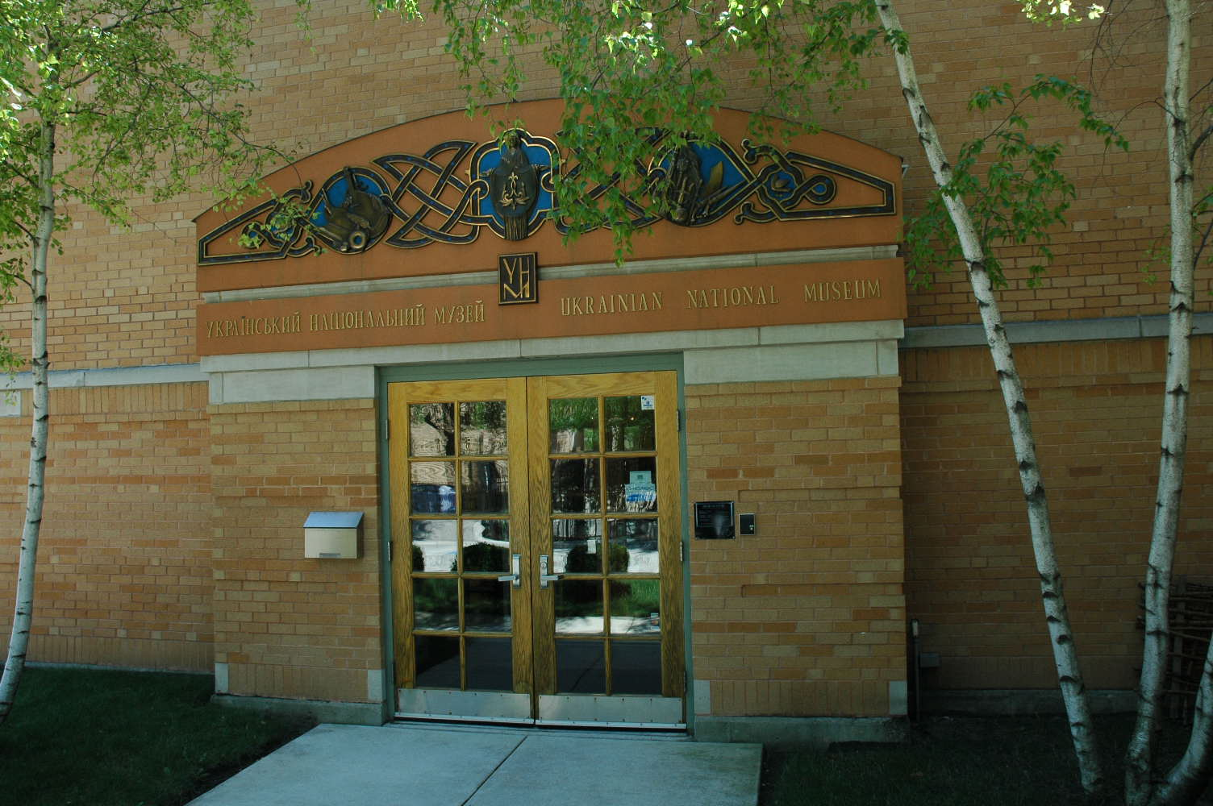
Across the street from St. Volodomir (to the south) is the National Ukrainian Museum. The curator (a middle-aged woman) came as a displaced person, but the docent (a younger woman) came because of family. Our docent was gynecologist at home, but has yet to take her medical boards here. The Museum had a temporary exhibit (they rotate monthly) of Ukrainian record album art. There were permanent displays of Pysanky (Ukrainian Easter eggs), Folk Arts (including a doll collection of native costumes), retired State Senator Walter Dudycz’s Springfield office, an exhibit on the Soviet famine-genocide due to farm collectivization, a library of books in Ukrainian, and a room of military history, including portraits of Ukrainian Cossacks and Nazi soldiers (Ukrainians joined the Nazis because they were fighting the Ukrainian’s enemy, the Russians).
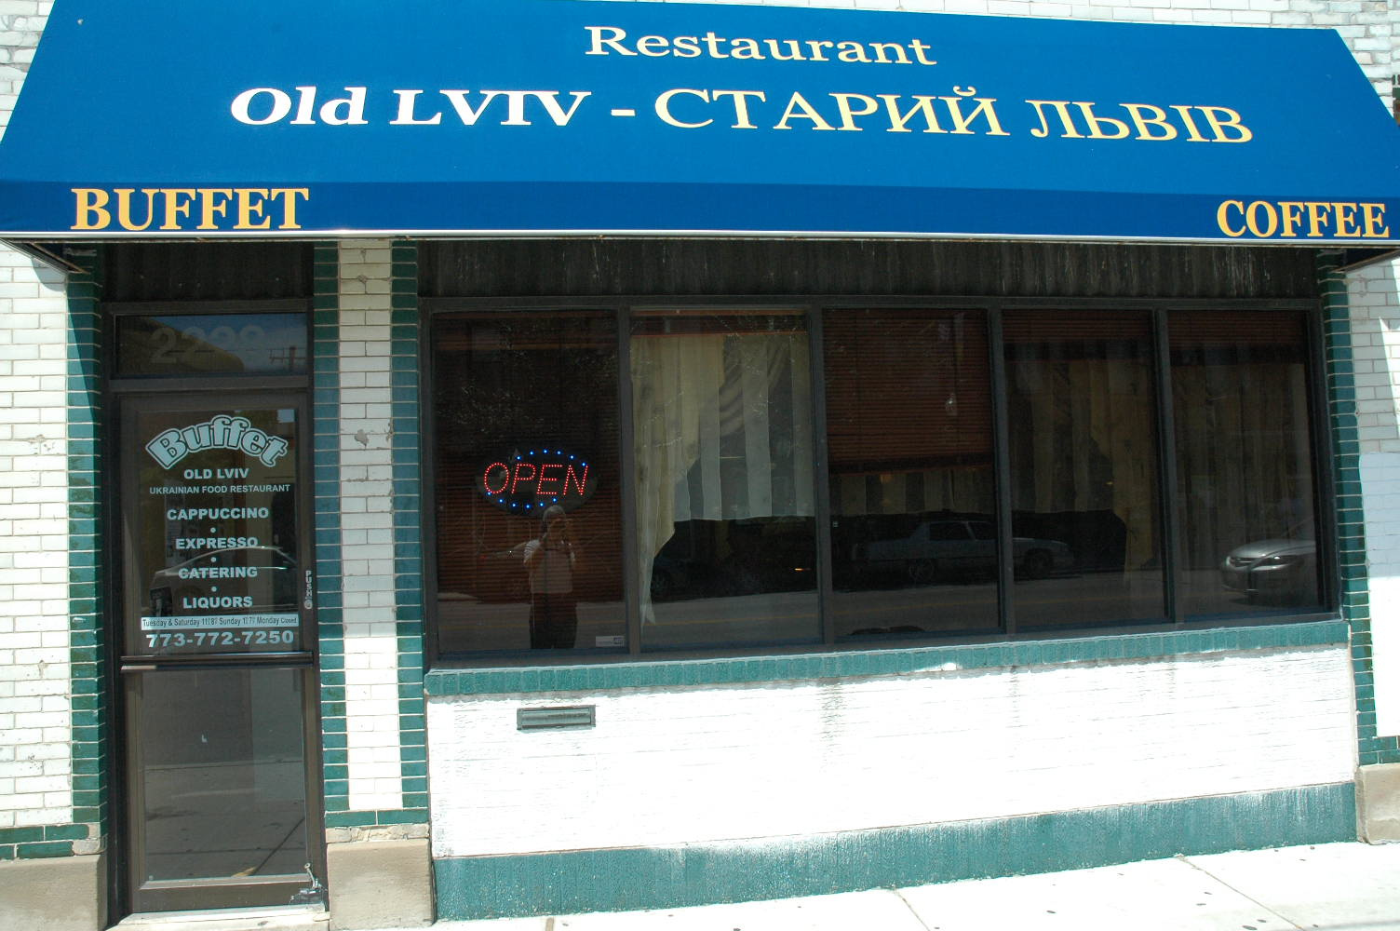
For lunch, we stopped at Old Lviv (on the recommendation of Svetlana, the journalist. It had white tablecloths, china service, and 5 tables. Lunch was a buffet, with borscht, blintzes, stuffed breaded grape leaves, slaw, horseradish beets, and apple pancake.

Interpretation & Analysis

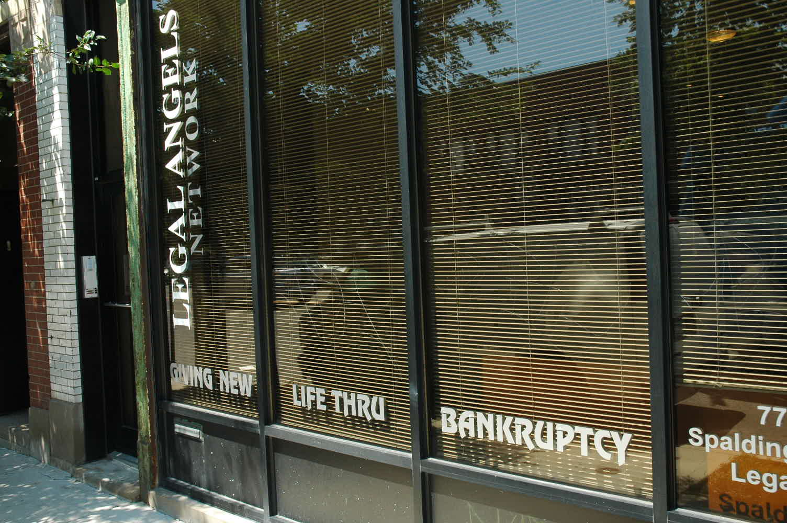
Although there are signs posted throughout the neighborhood identifying the Ukrainian Village, there is no bright line where the Ukrainians end and other groups start. The two churches are clearly the center of the life of the village (most of the Ukrainian stores & other institutions are located on Chicago Ave., in the shadow of the onion domes of St. Nicholas). The neighborhood appears to be prosperous and cohesive, with a significant ethic of looking out for each other. On the other hand, there are also signs of stress—the two parishes, the “for rent”signs, the explanation that at least some of the homeowners have been overextended by the recession, and even the posted signs about cleaning up after your dog (they may have been aimed at the young professionals who have been moving into the neighborhood recently). Many of these people, successful back home, came here to seek a new, even better life. There may be a bitter irony in the sign on a lawyers display window on Chicago Ave., “New life through bankruptcy.”

At the Ukrainian Museum, the docent stressed the horror of the mass starvation of up to 10 million Ukrainian kulaks (small, independent farmowners) brought on by Stalin’s collectivization of farmland in the early 1930s. Yet there is no mention of the 1.6-2.7 million Ukrainian Jews who were killed in Holocaust—led there, in part, by those Ukrainian Nazi officers whose portraits hang in the military display.

Reflection

I recognize this community. I grew up in a Catholic neighborhood in Detroit that was half Irish, half Italian, and half Jewish (and the math and theology worked). And I regularly visited my immigrant grandparents who lived in an ethnic Yugoslav (as it was then called) neighborhood in DesPlaines. This sense of a local community of extended kin (whether or not by blood, we were all family), who have a responsibility to each other for social welfare & community support, is familiar to me. I also spent my high school with classmates who spoke Polish, and I found that my Polish (which is close the Croatian my grandparents spoke) was close to Ukrainian. When I said “Dzen kuye” (thank you), they corrected my Ukrainian and replied “Dze Kyu.”

